1.Full adder

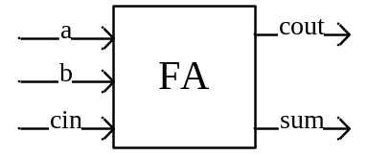

TRUTH TABLE
a | b | cin | cout | sum
0 | 0 | 0 | 0 | 0
0 | 0 | 1 | 0 | 1
0 | 1 | 0 | 0 | 1
0 | 1 | 1 | 1 | 0
1 | 0 | 0 | 0 | 1
1 | 0 | 1 | 1 | 0
1 | 1 | 0 | 1 | 0
1 | 1 | 1 | 1 | 1

cout = a’bcin + abcin’ + ab’cin + abcin
cin ab | 00 | 01 | 11 | 10
0 |  |  | 1
1 |  | 1 | 1 | 1

Cout = bcin + acin + ab

Sum = a’b’cin + a’bcin’ + abcin’ + abcin
cin ab | 00 | 01 | 11 | 10
0 |  | 1 |  | 1
1 | 1 |  | 1

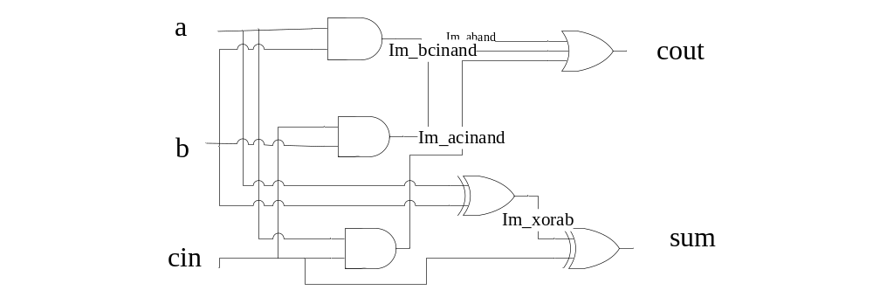

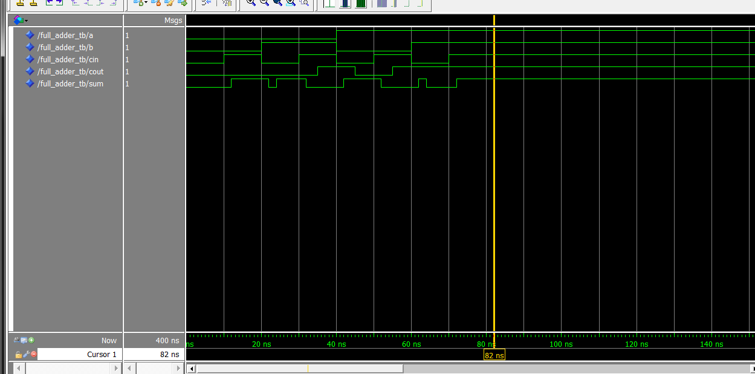

Code:
entity full_adder is
port(a,b,cin : in bit;
cout,sum: out bit);
end entity;

architecture dataflow of full_adder is
component and2 is
port(a, b : in bit;
c : out bit);
end component;

component xor_gate is
port(a, b : in bit;
c : out bit);
end component;

component or3_gate is
port(a, b, c: in bit;
d : out bit);
end component;

--signal declaration
signal im_a_and_b : bit;
signal im_a_and_cin : bit;
signal im_b_and_cin : bit;
signal im_a_xor_b : bit;

--binding
for all: xor_gate use entity work.xor_gate(dataflow);
for all: and2 use entity work.and2(dataflow);
for all: or3_gate use entity work.or3_gate(dataflow);

begin
c1: and2 port map(a,b,im_a_and_b);
c2: and2 port map(a,cin,im_a_and_cin);
c3: and2 port map(b,cin,im_b_and_cin);

c: or3_gate port map(im_a_and_b, im_a_and_cin, im_b_and_cin, cout);

c4: xor_gate port map(a,b,im_a_xor_b);

s: xor_gate port map(im_a_xor_b, cin, sum);

end dataflow;

testbench:
entity full_adder_tb is
end entity;

architecture io of full_adder_tb is

component full_adder is
port(a,b,cin : in bit;
cout,sum: out bit);
end component;

--signal declaration
signal a : bit;
signal b : bit;
signal cin : bit;
signal cout : bit;
signal sum : bit;

--binding
for all: full_adder use entity work.full_adder(dataflow);

begin
c1: full_adder port map(a,b,cin,cout,sum);

a <= '0','0' after 10ns, '0' after 20ns, '0' after 30ns, '1' after 40ns, '1' after 50ns, '1' after 60ns, '1' after 70ns;
b <= '0','0' after 10ns, '1' after 20ns, '1' after 30ns, '0' after 40ns, '0' after 50ns, '1' after 60ns, '1' after 70ns;
cin <= '0','1' after 10ns, '0' after 20ns, '1' after 30ns, '0' after 40ns, '1' after 50ns, '0' after 60ns, '1' after 70ns;

end io;

2. 2X4 decoder
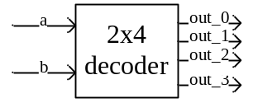

Truth table
A | B | Out_0 | Out_1 | Out_2 | Out_3
0 | 0 | 1 | 0 | 0 | 0
0 | 1 | 0 | 1 | 0 | 0
1 | 0 | 0 | 0 | 1 | 0
1 | 1 | 0 | 0 | 0 | 1

out_0 = a’b’ out_1 = a’b out_2=ab’ out_3 = ab
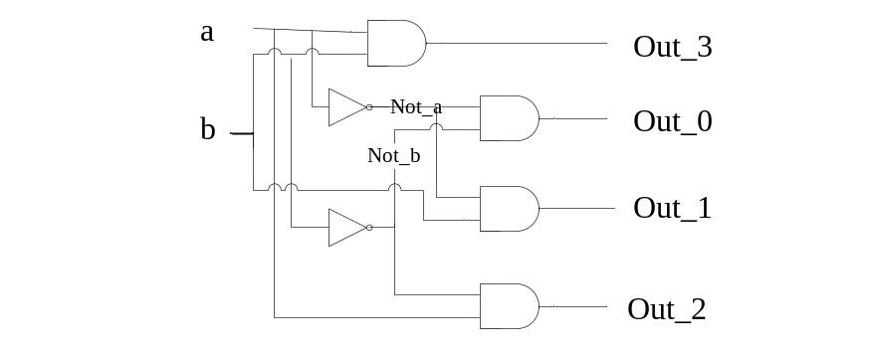

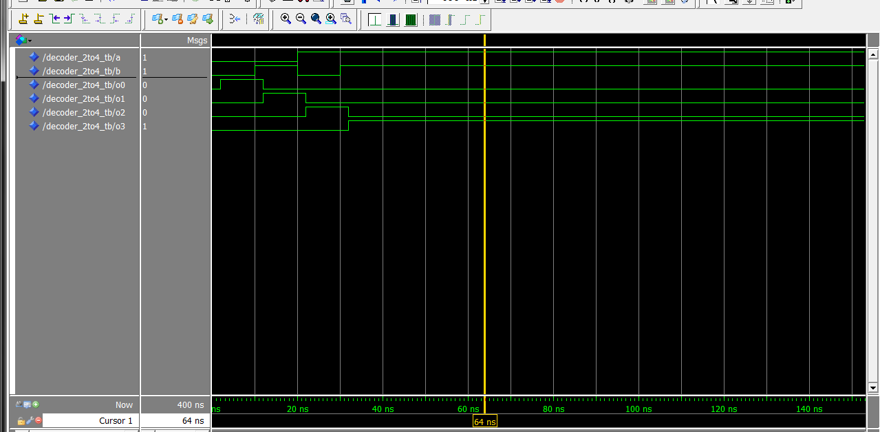
Code:
entity decoder_2to4 is
port(a, b : in bit;
out0, out1, out2, out3 : out bit);
end entity;

architecture dataflow of decoder_2to4 is
component and2 is
port(a, b : in bit;
c : out bit);
end component;

component not_gate is
port(a: in bit;
c: out bit);
end component;

for all: and2 use entity work.and2(dataflow);
for all: not_gate use entity work.not_gate(dataflow);

signal not_a, not_b : bit;

begin
c1: not_gate port map(a,not_a);
c2: not_gate port map(b,not_b);

c3: and2 port map(not_a, not_b, out0);
c4: and2 port map(not_a, b, out1);
c5: and2 port map(a, not_b, out2);
c6: and2 port map(a, b, out3);

end dataflow;

testbench:
entity decoder_2to4_tb is
end entity;

architecture io of decoder_2to4_tb is

component decoder_2to4 is
port(a, b : in bit;
out0, out1, out2, out3 : out bit);
end component;

for all: decoder_2to4 use entity work.decoder_2to4(dataflow);

signal a,b,o0,o1,o2,o3: bit;

begin
c1: decoder_2to4 port map(a,b,o0,o1,o2,o3);

a <= '0', '0' after 10ns, '1' after 20ns, '1' after 30ns;
b <= '0', '1' after 10ns, '0' after 20ns, '1' after 30ns;
end io;

3. 4to1 MUX

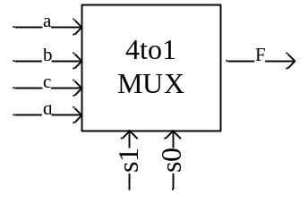

Truth table
S1 | S2 | F
0 | 0 | A
0 | 1 | B
1 | 0 | C
1 | 1 | D

F = as1’s0’ + bs1’s0 +cs1s0’ +ds1s0

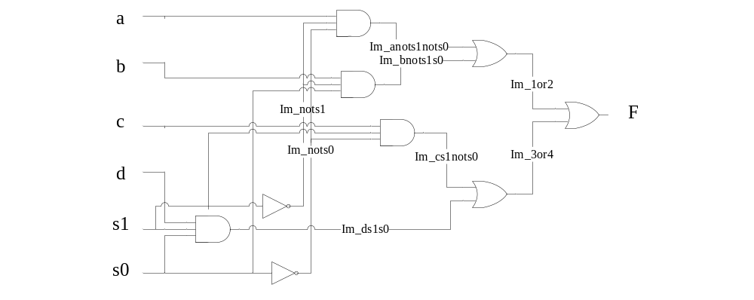

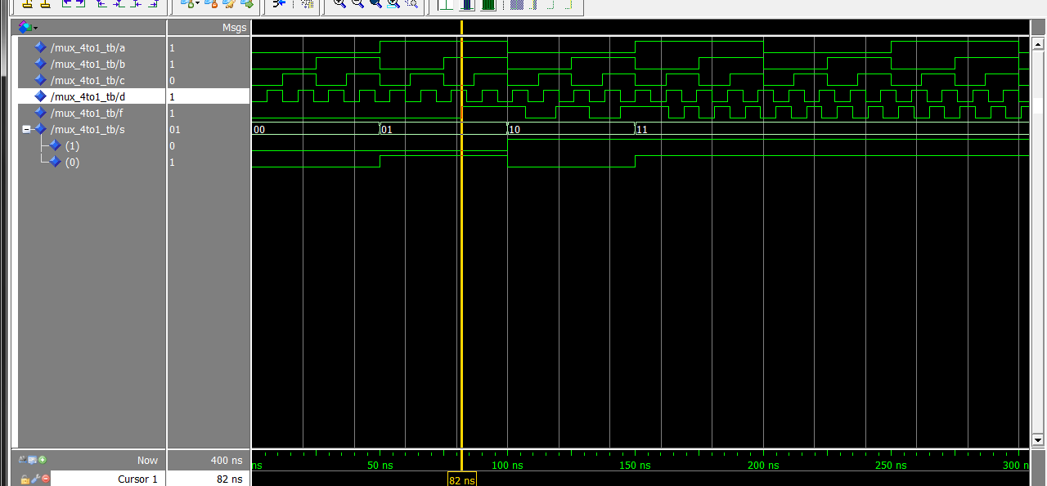

Code:
entity mux_4to1 is
port(a,b,c,d : in bit;
s : in bit_vector(1 downto 0);
f : out bit);
end mux_4to1;

architecture dataflow of mux_4to1 is
component and3_gate is
port(a,b,c: in bit;
d: out bit);
end component;

component or2 is
port(a,b: in bit;
c: out bit);
end component;

component not_gate is
port(a: in bit;
c: out bit);
end component;

for all: and3_gate use entity work.and3_gate(dataflow);
for all: or2 use entity work.or2(dataflow);
for all: not_gate use entity work.not_gate(dataflow);

signal im_not_s0, im_not_s1, im_anots1nots0, im_bnots1s0, im_cs1nots0, im_ds1s0, im_1or2, im_3or4 : bit;

begin
c1: not_gate port map(s(0),im_not_s0);
c2: not_gate port map(s(1),im_not_s1);

c3: and3_gate port map(a,im_not_s0,im_not_s1,im_anots1nots0);
c4: and3_gate port map(b,s(0),im_not_s1,im_bnots1s0);
c5: and3_gate port map(c,s(1),im_not_s0,im_cs1nots0);
c6: and3_gate port map(d,s(0),s(1),im_ds1s0);

c7: or2 port map(im_anots1nots0, im_bnots1s0, im_1or2);
c8: or2 port map(im_cs1nots0, im_ds1s0, im_3or4);

c9: or2 port map(im_1or2, im_3or4, f);

end dataflow;

testbench:
entity mux_4to1_tb is
end entity;

architecture io of mux_4to1_tb is
component mux_4to1 is
port(a,b,c,d : in bit;
s : in bit_vector(1 downto 0);
f : out bit);
end component;

for all: mux_4to1 use entity work.mux_4to1(dataflow);

signal a,b,c,d,f : bit;
signal s : bit_vector(1 downto 0);

begin
c1: mux_4to1 port map(a,b,c,d,s,f);

a <= '1','0' after 10ns, '1' after 20ns, '0' after 30ns,'1' after 40ns, '0' after 50ns;
b <= '1','0' after 10ns, '1' after 20ns, '0' after 30ns,'1' after 40ns, '0' after 50ns;
c <= '1','0' after 10ns, '1' after 20ns, '0' after 30ns,'1' after 40ns, '0' after 50ns;
d <= '1','0' after 10ns, '1' after 20ns, '0' after 30ns,'1' after 40ns, '0' after 50ns;
s <= "00","01" after 50ns,"10" after 100ns, "11" after 150ns;

end io;

4. simple gates
4.1 and2
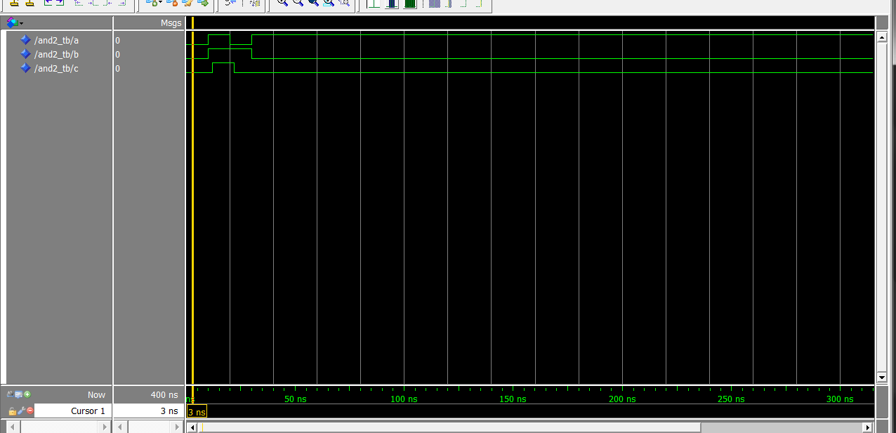

Code:
entity and2 is
port(a, b : in bit;
c : out bit);
end and2;

architecture dataflow of and2 is
begin
c <= a and b after 2ns;
end dataflow;

testbench:
entity and2_tb is
end entity;

architecture io of and2_tb is
component and2
port(a, b : in bit;
c : out bit);
end component;

for all : and2 use entity work.and2(dataflow);
signal a: bit;
signal b: bit;
signal c: bit;

begin
c1: and2 port map(a ,b, c);

a <= '0','1' after 10ns,'0' after 20ns, '1' after 30ns;
b <= '0','1' after 10ns,'1' after 20ns, '0' after 30ns;
end io;

4.2 nand2
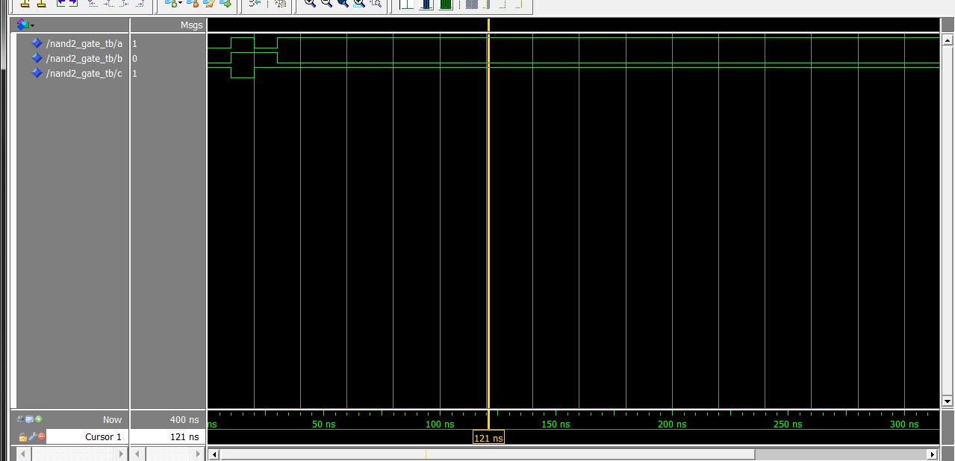

Code:
entity nand2_gate is
port(a,b: in bit;
c: out bit);
end nand2_gate;

architecture dataflow of nand2_gate is

begin
c <= a nand b;
end dataflow;

testbench:
entity nand2_gate_tb is
end entity;

architecture io of nand2_gate_tb is
component nand2_gate is
port(a,b: in bit;
c: out bit);
end component;

for all: nand2_gate use entity work.nand2_gate(dataflow);

signal a : bit;
signal b : bit;
signal c : bit;

begin
c1: nand2_gate port map(a,b,c);

a <= '0','1' after 10ns,'0' after 20ns, '1' after 30ns;
b <= '0','1' after 10ns,'1' after 20ns, '0' after 30ns;
end io;

4.3 gate3
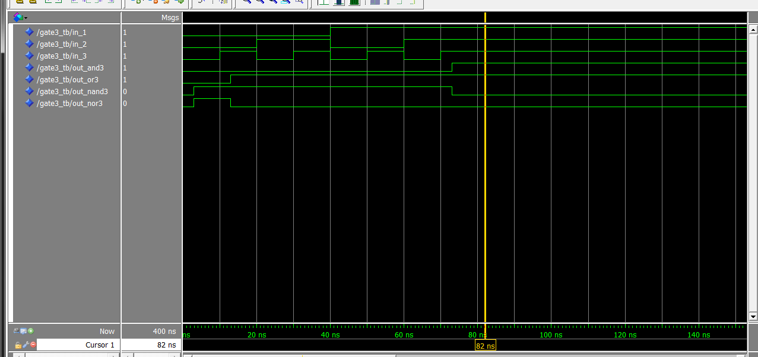
Code:
And3:
entity and3_gate is
port(a,b,c: in bit;
d: out bit);
end entity;

architecture dataflow of and3_gate is
begin
d <= a and b and c after 3ns;
end dataflow;

nand3:
entity nand3_gate is
port(a,b,c: in bit;
d: out bit);
end entity;

architecture dataflow of nand3_gate is
signal im0 : bit;
begin
im0 <= a and b and c;
d <=not im0 after 3ns;
end dataflow;

nor3:
entity nor3_gate is
port(a,b,c: in bit;
d: out bit);
end entity;

architecture dataflow of nor3_gate is
signal im0 : bit;
begin
im0 <= a or b or c;
d <= not im0 after 3ns;
end dataflow;

or3:
entity or3_gate is
port(a,b,c: in bit;
d: out bit);
end entity;

architecture dataflow of or3_gate is
begin
d <= ((a or b) or c )after 3ns;
end dataflow;

entity gate3_tb is
end entity;

testbench:
architecture io of gate3_tb is

component and3_gate is
port(a,b,c: in bit;
d: out bit);
end component;

component or3_gate is
port(a,b,c: in bit;
d: out bit);
end component;

component nand3_gate is
port(a,b,c: in bit;
d: out bit);
end component;

component nor3_gate is
port(a,b,c: in bit;
d: out bit);
end component;

signal in_1 : bit;
signal in_2 : bit;
signal in_3 : bit;
signal out_and3 : bit;
signal out_or3 : bit;
signal out_nand3 : bit;
signal out_nor3 : bit;

--binding
for all: and3_gate use entity work.and3_gate(dataflow);
for all: or3_gate use entity work.or3_gate(dataflow);
for all: nand3_gate use entity work.nand3_gate(dataflow);
for all: nor3_gate use entity work.nor3_gate(dataflow);

begin
c1: and3_gate port map(in_1,in_2,in_3,out_and3);
c2: or3_gate port map(in_1,in_2,in_3,out_or3);
c3: nand3_gate port map(in_1,in_2,in_3,out_nand3);
c4: nor3_gate port map(in_1,in_2,in_3,out_nor3);

in_1 <= '0','0' after 10ns, '0' after 20ns, '0' after 30ns, '1' after 40ns, '1' after 50ns, '1' after 60ns, '1' after 70ns;
in_2 <= '0','0' after 10ns, '1' after 20ns, '1' after 30ns, '0' after 40ns, '0' after 50ns, '1' after 60ns, '1' after 70ns;
in_3 <= '0','1' after 10ns, '0' after 20ns, '1' after 30ns, '0' after 40ns, '1' after 50ns, '0' after 60ns, '1' after 70ns;

end io;

4.4 nor2
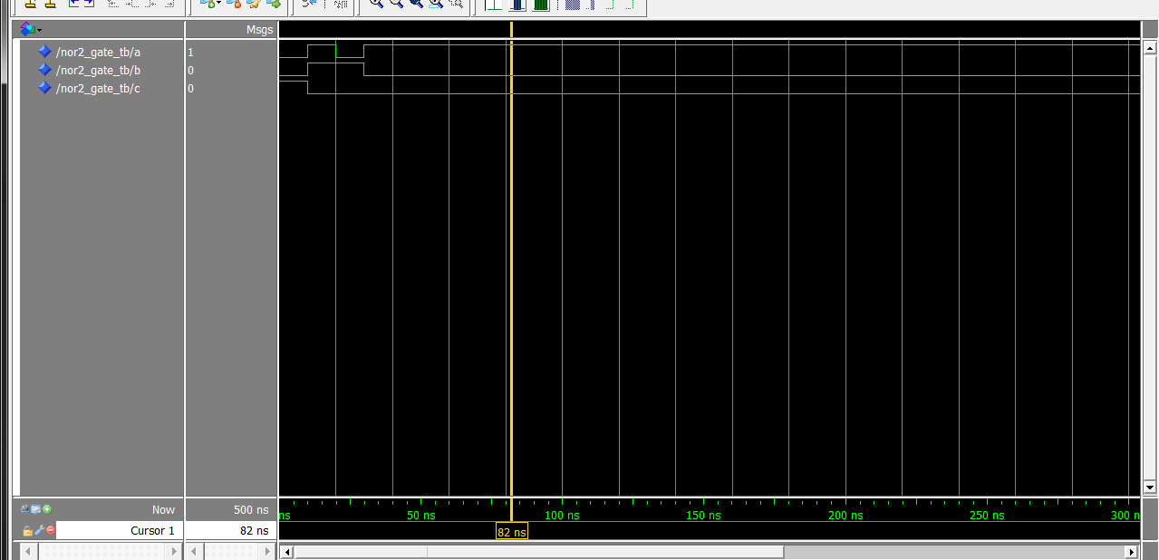
Code:
entity nor2_gate is
port(a,b: in bit;
c: out bit);
end nor2_gate;

architecture dataflow of nor2_gate is

begin
c <= a nor b;
end dataflow;

testbench:
entity nor2_gate_tb is
end entity;

architecture io of nor2_gate_tb is
component nor2_gate is
port(a,b: in bit;
c: out bit);
end component;

for all: nor2_gate use entity work.nor2_gate(dataflow);

signal a: bit;
signal b: bit;
signal c: bit;

begin
c1: nor2_gate port map(a,b,c);

a <= '0','1' after 10ns,'0' after 20ns, '1' after 30ns;
b <= '0','1' after 10ns,'1' after 20ns, '0' after 30ns;
end io;

4.5 not_gate(test bench include and2)
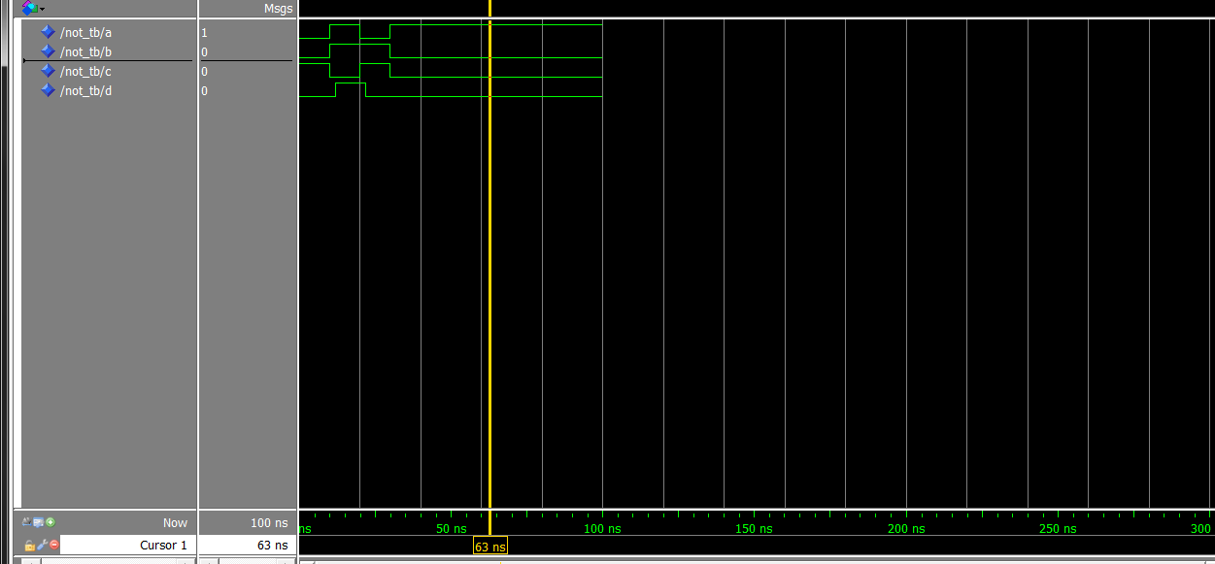
Code:
entity not_gate is
port(a: in bit;
c: out bit);
end not_gate;

architecture dataflow of not_gate is
begin
c <= not a;
end dataflow;

testbench:
entity not_tb is
end entity;

architecture io of not_tb is
component not_gate is
port(a: in bit;
c: out bit);
end component;

component and2 is
port(a,b: in bit;
c: out bit);
end component;

for all: not_gate use entity work.not_gate(dataflow);
for all: and2 use entity work.and2(dataflow);

signal a: bit;
signal b: bit;
signal c: bit;
signal d: bit;

begin
c1: not_gate port map(a,c);
c2: and2 port map(a,b,d);

a <= '0','1' after 10ns,'0' after 20ns, '1' after 30ns;
b <= '0','1' after 10ns,'1' after 20ns, '0' after 30ns;
end io;

4.6 or2
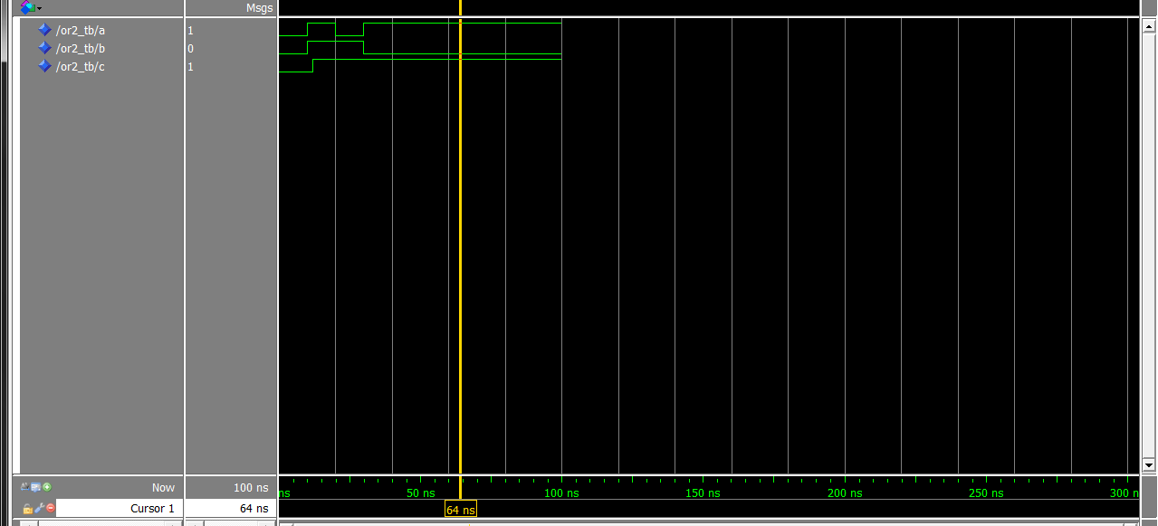
Code:
entity or2 is
port(a,b : in bit;
c : out bit);
end or2;

architecture dataflow of or2 is

begin
c <= a or b after 2ns;
end dataflow;

testbench:
entity or2_tb is
end entity;

architecture io of or2_tb is
component or2
port(a,b : in bit;
c : out bit);
end component;

for all: or2 use entity work.or2(dataflow);

signal a : bit;
signal b : bit;
signal c : bit;

begin
c1: or2 port map(a,b,c);

a <= '0','1' after 10ns,'0' after 20ns, '1' after 30ns;
b <= '0','1' after 10ns,'1' after 20ns, '0' after 30ns;
end io;

4.7 xor_gate
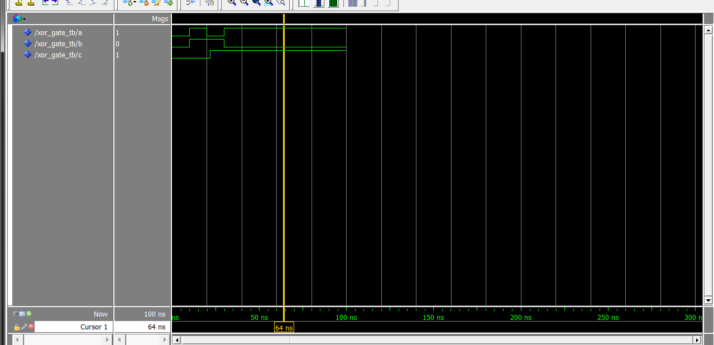

Code:
entity xor_gate is
port(a,b: in bit;
c: out bit);
end entity;

architecture dataflow of xor_gate is
begin
c<= a xor b after 2ns;
end dataflow;

testbench:
entity xor_gate_tb is
end entity;

architecture io of xor_gate_tb is
component xor_gate is
port(a,b: in bit;
c: out bit);
end component;

for all: xor_gate use entity work.xor_gate(dataflow);

signal a : bit;
signal b : bit;
signal c : bit;

begin
c1: xor_gate port map(a,b,c);

a <= '0','1' after 10ns,'0' after 20ns, '1' after 30ns;
b <= '0','1' after 10ns,'1' after 20ns, '0' after 30ns;
end io;

